192312464
Akshay Deep

Simulation Task: LTE throughput performance under varying bandwidth, SNR,modulation order, coding rate, and user load
Aim: To simulate the LTE throughput performance by analyzing the effect of SNR and bandwidth using MATLAB and to plot the corresponding throughput graphs.
Program:
clc;
clear;
close all;

% Parameters
SNR = 0:5:30; % dB
Bandwidth = [1.4 3 5 10 15 20]; % MHz

%% Graph 1: Throughput vs SNR
throughput1 = 20 * log2(1 + 10.^(SNR/10));

figure;
plot(SNR, throughput1, '-o', 'LineWidth', 2);
grid on;
xlabel('SNR (dB)');
ylabel('Throughput (Mbps)');
title('LTE Throughput vs SNR');

%% Graph 2: Throughput vs Bandwidth
throughput2 = Bandwidth * 15;

figure;
plot(Bandwidth, throughput2, '-s', 'LineWidth', 2);
grid on;
xlabel('Bandwidth (MHz)');
ylabel('Throughput (Mbps)');
title('LTE Throughput vs Bandwidth');

Output1:
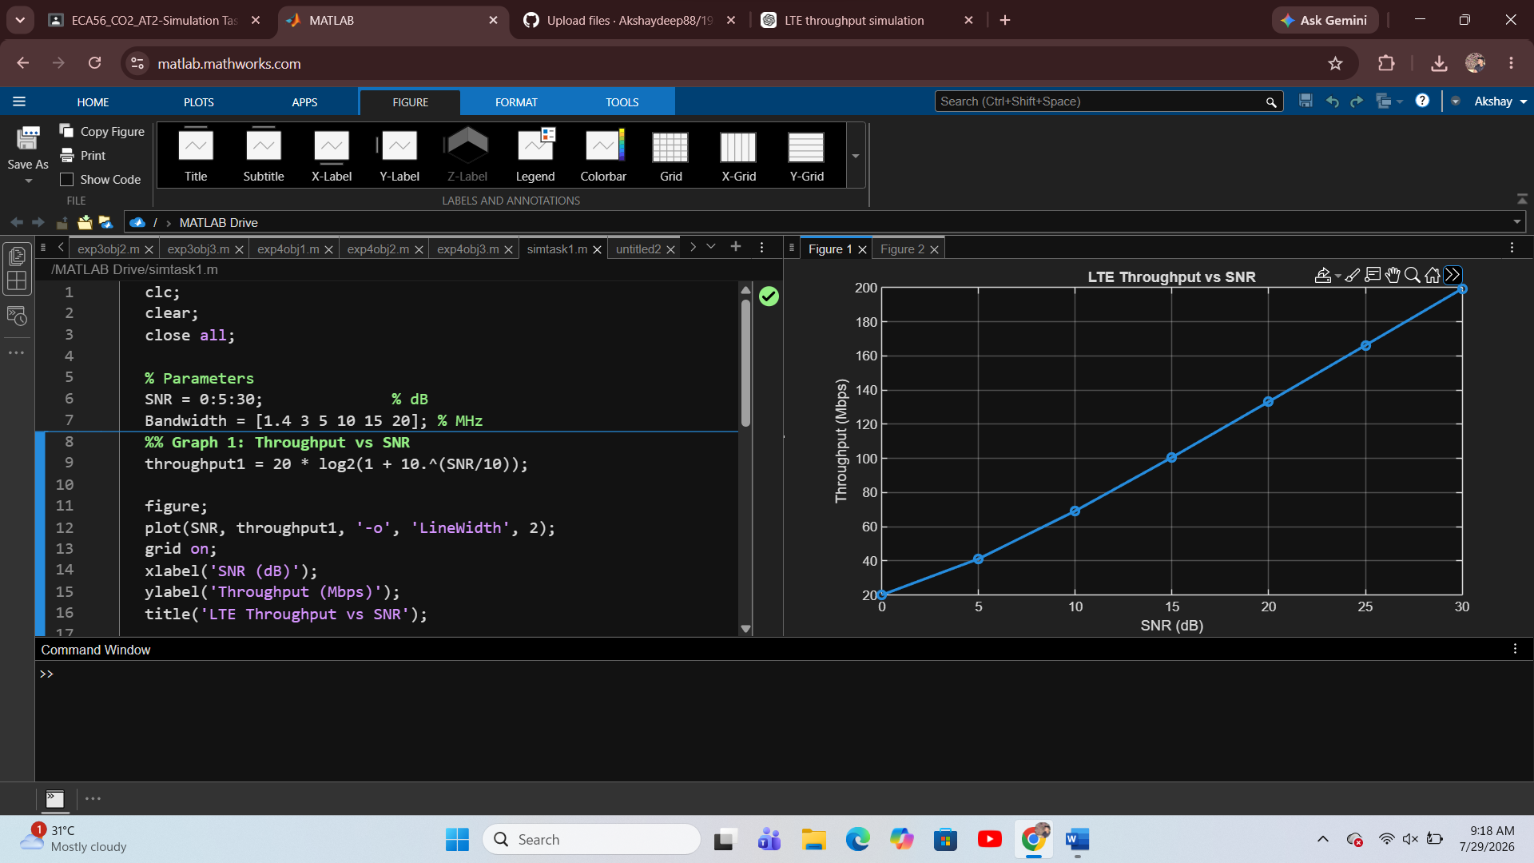
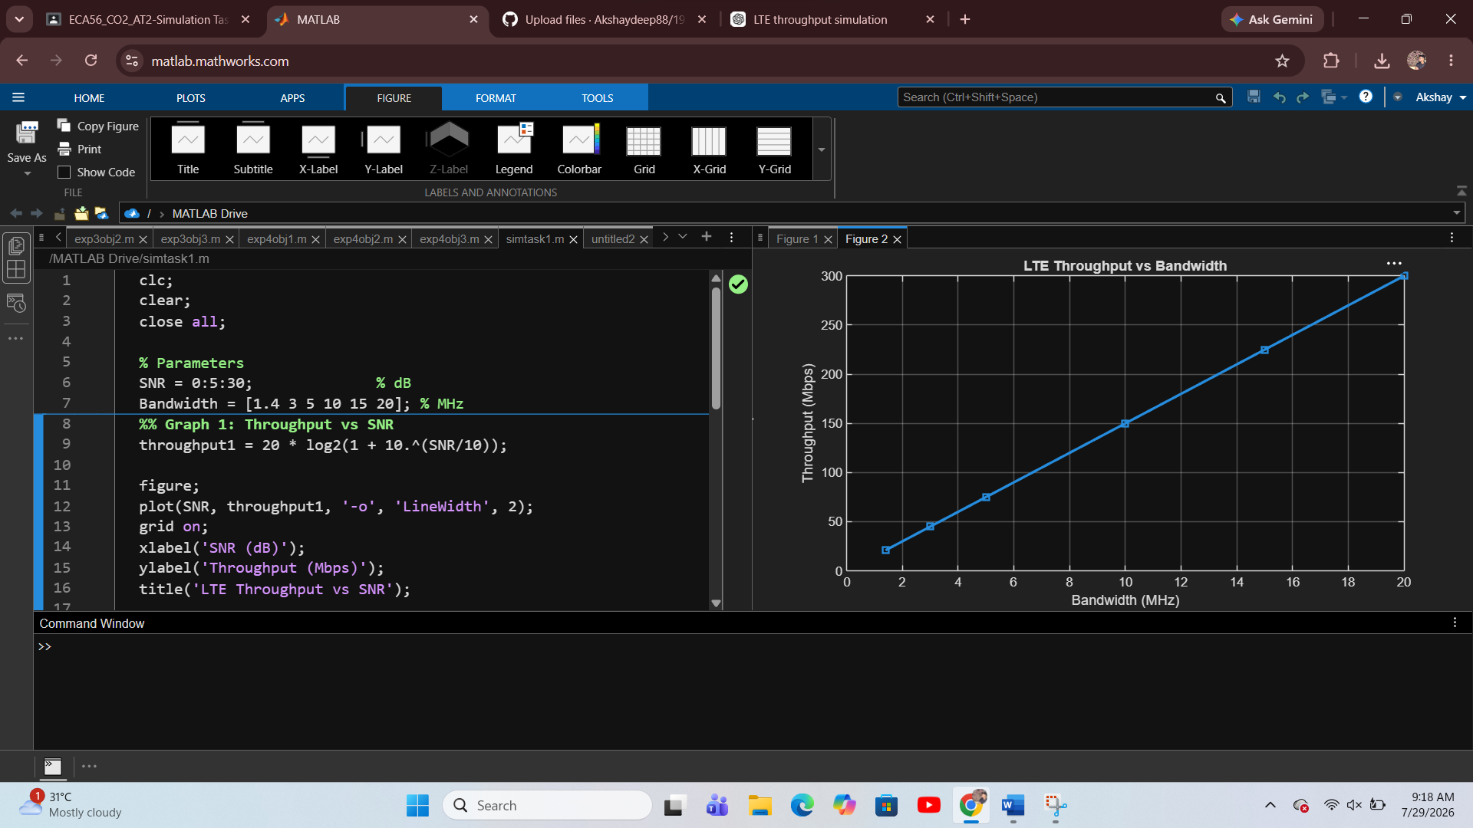
Result:
The MATLAB simulation was executed successfully. The graphs showed that LTE throughput increases with increasing SNR and bandwidth. Higher SNR improves signal quality, resulting in greater throughput, while increasing bandwidth provides more transmission capacity, thereby enhancing the overall LTE network throughput.

